**Context Menus**

Table Menus:

Each table has a context (right-click menu). They all contain “Select All”, “Copy”, “Paste”, “Clear Contents”, and “Delete Row(s)”. The Reactions table also has a “Un-Highlight Participating Reactions” menu item. There are some columns that contain additional entries such as “Launch Reaction Editor” in the Reaction Equation (Metabolite Abbreviation) column, and “Rename”, “Highlight Participating Reactions”, and “Un-Highlight Participating Reactions” in the Metabolite Abbreviation and Metabolite Name columns.

Select All has two sub-menus with radio buttons: “Include Column Names” and “Selected Cells Only” so that the table contents can be copied into an external program such as Microsoft Excel with or without the column names.

Copy can also be executed with Ctrl-C or using the Copy icon on the toolbar.

Paste can also be executed with Ctrl-V or using the Copy icon on the toolbar.

Clear Contents can also be executed with Ctrl-E.

Delete Row(s) – rows cannot be deleted if they contain “used” metabolites – that is metabolites that participates in one or more reactions.

Rename will show a warning that if the name of a metabolite is changed, all reactions that contain the metabolite will be updated for the new name. Direct editing of the cell will open the same warning.

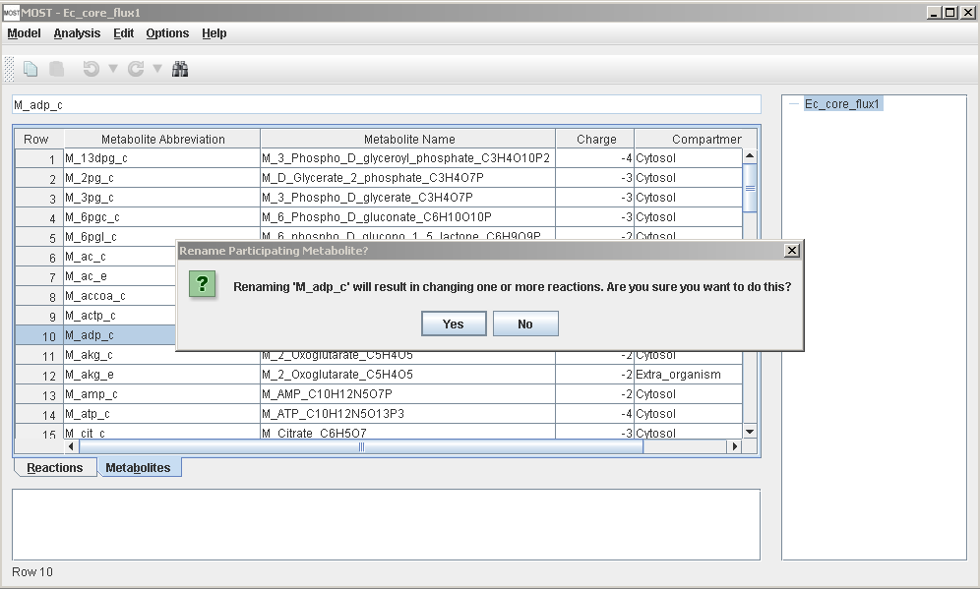

Click “Yes” to rename, “No” to cancel. If “Yes” is clicked, the Rename Metabolite dialog will appear.

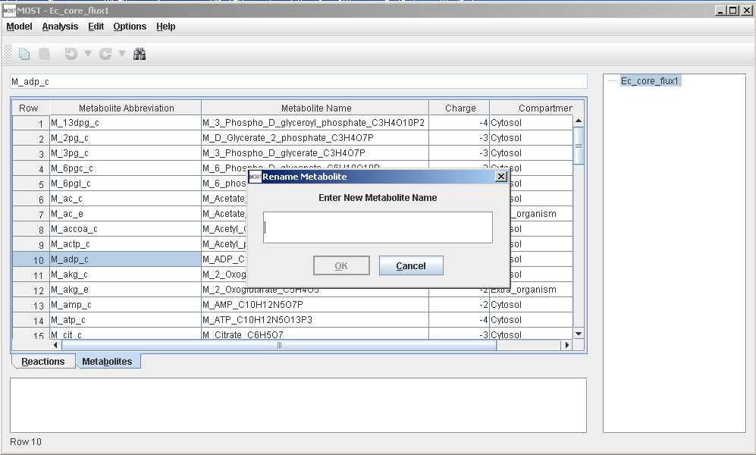

Highlight Participating Reactions will tab to the Reactions table, and scroll the first participating reaction of the selected metabolite into view. If the metabolite is unused, this menu item will be grayed out. If the selected cell is changed in the metabolites table, the reactions will be un-highlighted.

Un-Highlight Participating Reactions in either table will un-highlight reactions.

Launch Reaction Editor will launch the Reaction Editor. If the selected row is changed in the Reactions table, the Reaction Editor will close.

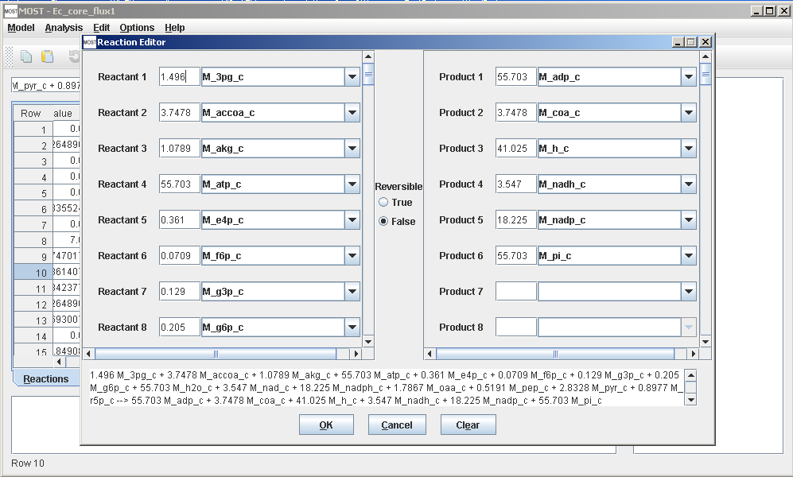

The Reaction Editor will make it easy to build a model from a set of existing metabolites in the Metabolites table. (If the Metabolites table is empty, the drop boxes will be empty.) When the drop boxes are edited, suggestions will appear in the drop down panel. Stoichiometric coefficients can be typed in to the coefficient text boxes to the left of the drop boxes. Reversible can be changed by the Reversible radio buttons in the center. Click “OK” to enter the reaction in the Reactions table, “Cancel” to cancel editing the reaction, “Clear” to clear all the drop boxes and lower panel.

Column Header Menus:

Column Headers have a context menu with “Delete Column”, but columns can only be deleted if they are not core columns, so this menu item will be grayed out on core columns.

Console Menu:

The console is where the output information is displayed after running FBA or GDBB in the Analysis menu. The console (lower pane) also has a context menu that contains “Copy”, “Select All” that allow the contents to be copied. “Pop Out” will open a larger window that will display the contents of the console and save the contents as text (.txt) files

Tree Menu:

The top item in the tree panel (right pane) is the model name, and does not have a context menu. When Analyses are run, new items are added to the tree. All of these items have context menus